# **Javascript , JSON and databases**

## **Relational databases and sql**

When we're talking about relational data and databases typically we're talking about something like this, a table that has fields or that is to say columns and rows of data.

So in this people table, each person has an ID, a first name, a last name, and an address. But in properly formatted relational databases we try not to just stuff everything into one table, especially when we're repeating ourselves.

So for example, we might have a table of people and a table of addresses. And we connect with some kind of ID. So we say, "This address belongs to this person "based on the ID."

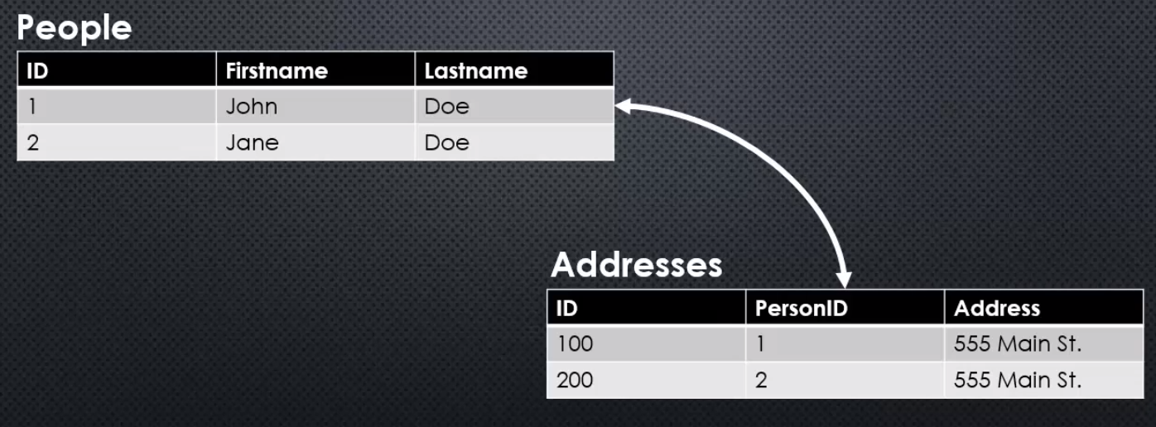

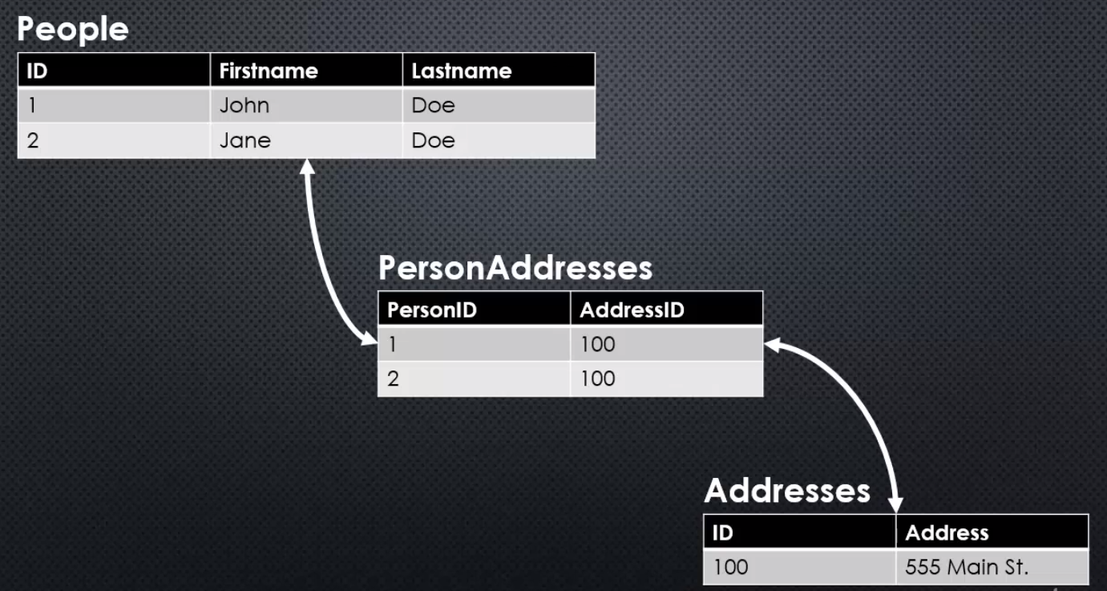

But even better, we can make sure we don't repeat ourselves by continuing to split the information up as much as possible. So I might have an addresses table, where we see that a person has a particular address. So we use the ID of the address and the ID of the person and we can also tell this way that two people live in the same house.

So this is what's called well-normalized data.

That is basically to say data that doesn't repeat itself unnecessarily. We minimise how much space we're taking up in the database and we structure our data in a way that makes it easy to ask interesting questions.

asking questions part is done in SQL, Structured Query Language. Where we ask a question of the database and it can come find those tables and get a result.

So this example query here, took those last three tables and actually got back the result that was our original not-so-good table. But this is the way we generally want to get our data back.

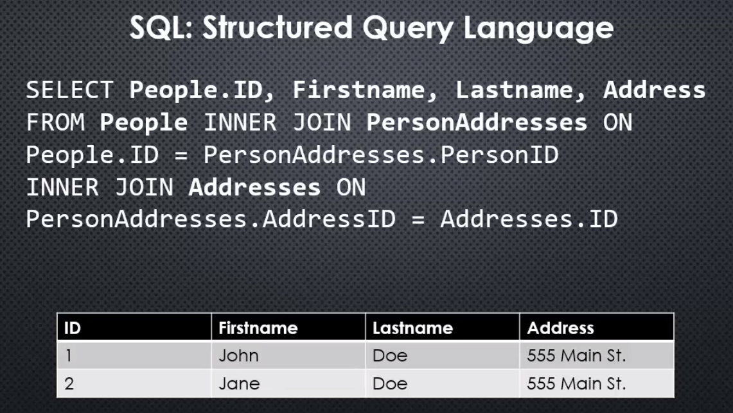

Now here's the question, if this is my data, how do I deal with it in JavaScript?

Well JavaScript has a way of storing data, it's called Objects. And so we can think of a table as an array, and then each item in the array is an object.

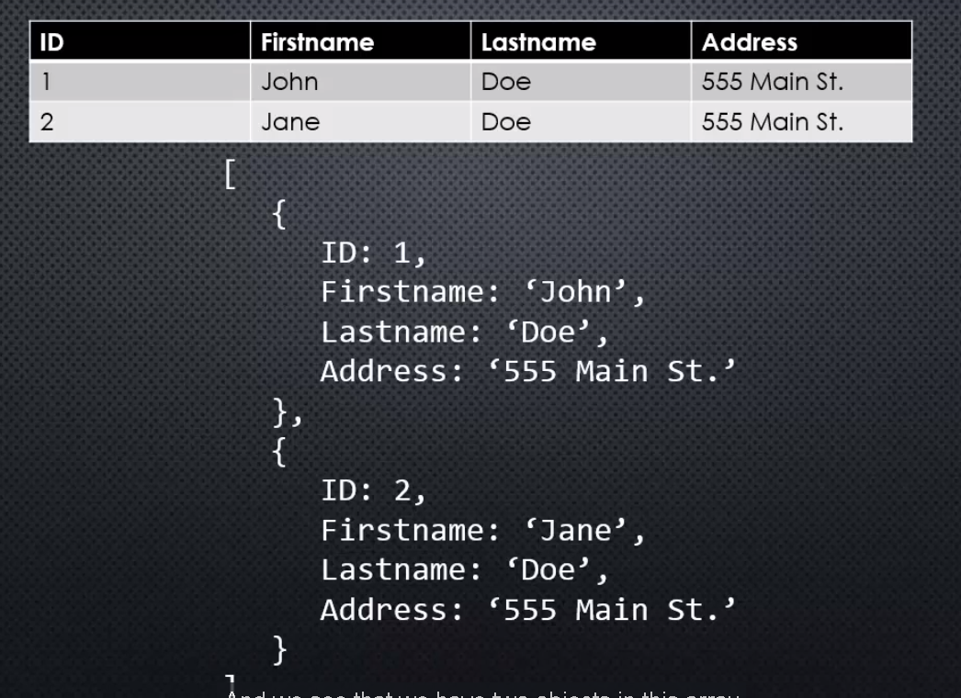

**So we just need something that is able to connect to the database and convert the tabular data into JavaScript Objects. And we can find that on the npm-registry.**

## **node and mySql**

a really good package for using MySQL in Node. **mysql** is an open source Sequel database.

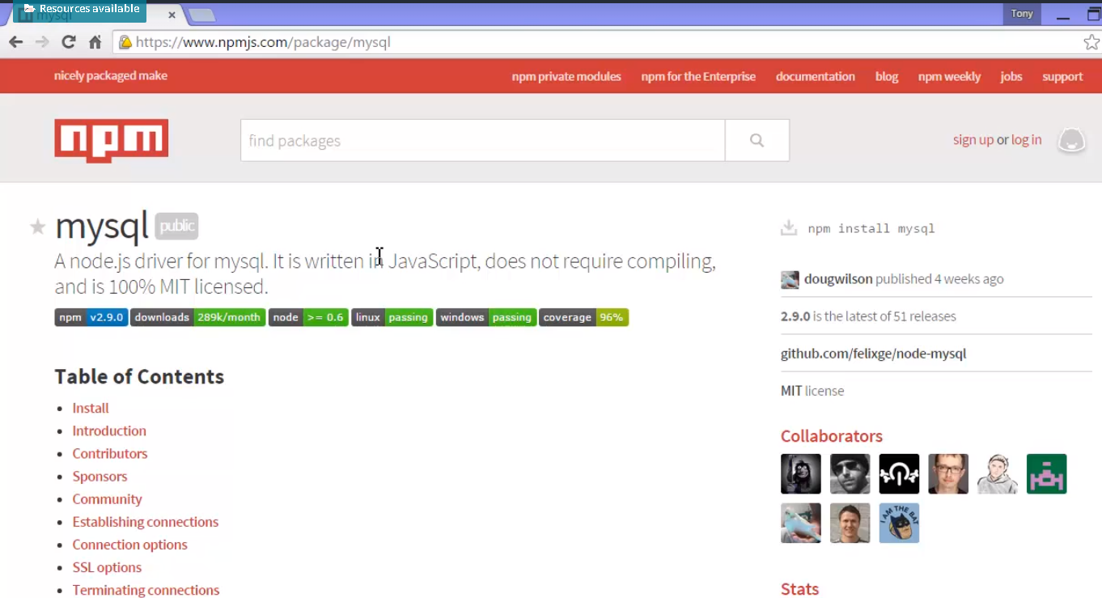

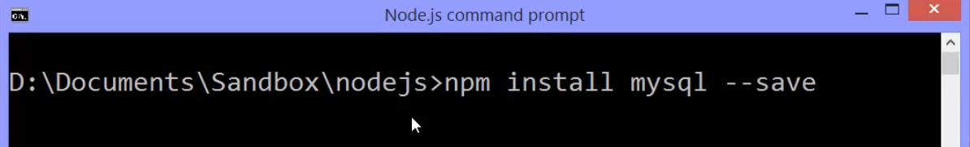

**Npm install mysql and It'll save it to the package dot json. It will install this and that's just JavaScript code that enables us to connect to a MySQL database, run a Sequel query, get the data back as JavaScript objects. And of course also add, update and delete data. MySQL is now in my node underscore modules folder.**

**It's also in my package dot json.**



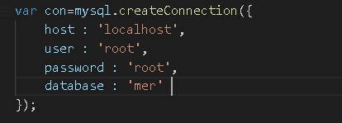

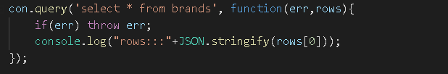

This should result the data from tables, I have my data in mysql below –

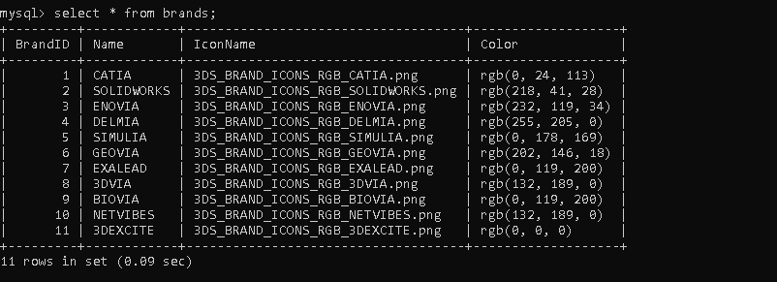

Output from node -



MySQL the database did send back tabular data and this package, this npm package took that data and converted it into a JavaScript array. Notice the brackets there. And it's an array that holds an object for every row in the table. And this is absolutely fantastic because that means all we have to think about now when it comes to using our data is what would I do with a JavaScript object? And we know how to deal with that.

So I could loop across this, I could send this over to my view, for example like we do with EJS, and send it across with the model. I could have this be something that happens in one of the doc gets on the app and simply use that as the data the data that I display. I could have this sent back via JSON to the browser and let the browser take this data and decide what to do with it in JavaScript on the browser.

**In fact, this particular package has the ability to stream rows so we're sending chunks at a time straight from the database and pipe it out to the HTTP response.**

## **NoSql and Documents**

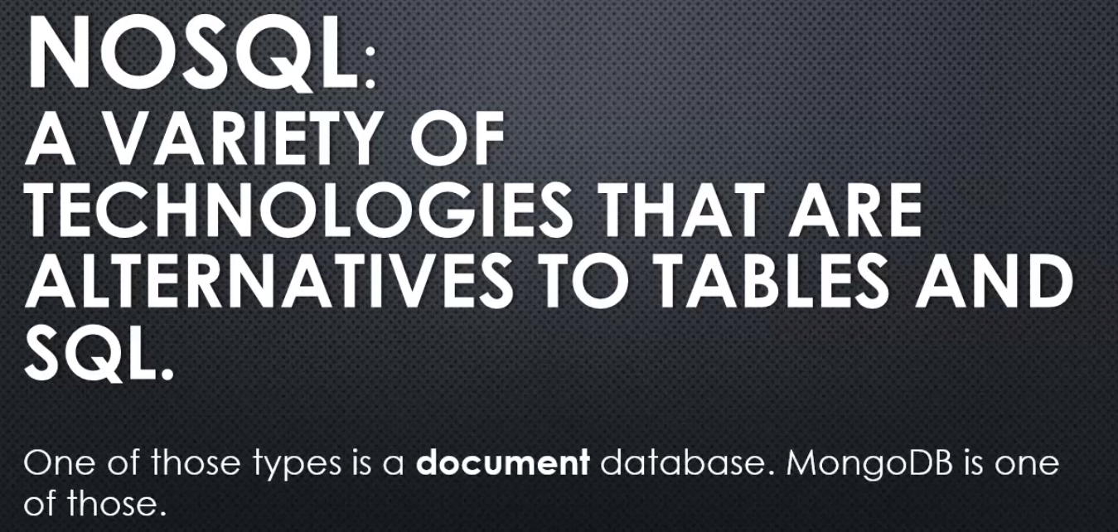

**NoSQL is this idea that we're not going to store data in tables with specific columns, fields.**

So what about a document database? Well, we've already seen the idea that we have a table and convert it to JSON. But what if we forgot the table concept entirely, and instead, made this what we store in the database?

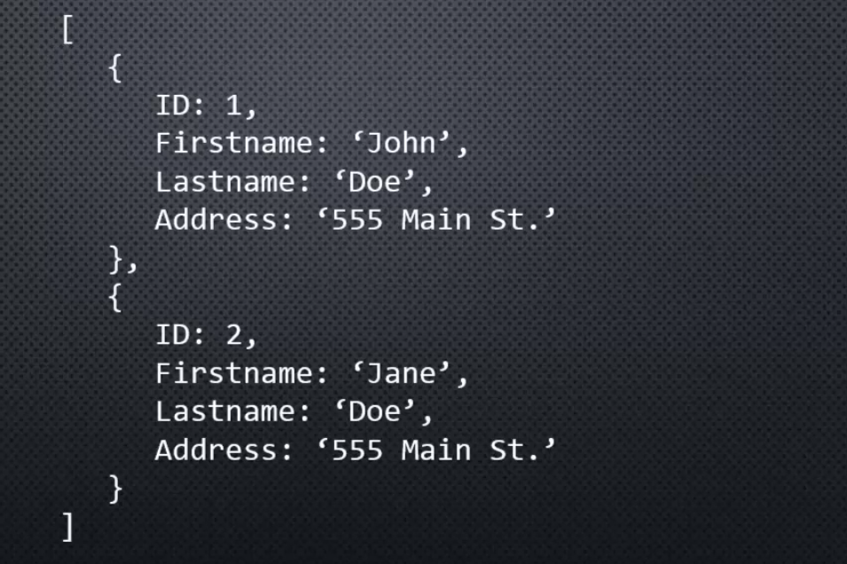

Essentially one of those objects would be a record in the database. A document, if you will.

**Why is that powerful?**

**Well in the old days with SQL databases, we were really worried about repeating information. So relational databases were great because repeated information meant more hard drive space, and we were trying to minimise that.**

**But a lot of time has passed since SQL databases first came about, and hard drive space is cheaper and significantly larger than it ever was. So that's not as big a concern as it used to be. Instead what we're more concerned with is how often we need to change software. Things change quickly. It's a modern technological world. And so when I need to add a new field to my database, with SQL databases that can be quite taxing and cumbersome. Or if my structure needs to change entirely at some point in time. But if I stored the data in a way that it contained both the structure and the data itself essentially, a document, almost like storing JSON, then I could add a field to one particular object and it wouldn't be a big deal because if I asked for it on another object, it would just be undefined, non-existent, null. But that would be okay, and I could change my structure on the fly, and still ask questions like, "Give me all the first names," as long as the fields are there.**

**So this idea of, we're going to sacrifice a bit of hard drive space for an extraordinary amount of flexibility, plus other reasons**, are reasons why NoSQL databases have come into existence and have gained traction and popularity. There's more than one, but one of them that's quite popular to use with NodeJS is called MongoDB.

## **MongoDb and Mongoose**

let's take a quick look at using MongoDB inside Node, and there's a few ways to do that but by far the most popular and perhaps the most powerful is an NPM package called **Mongoose.**

You can find out a lot more about Mongo by going to mongodb.com, and there you can also download MongoDB and install it on your local computer and there's instructions there on how to do that.

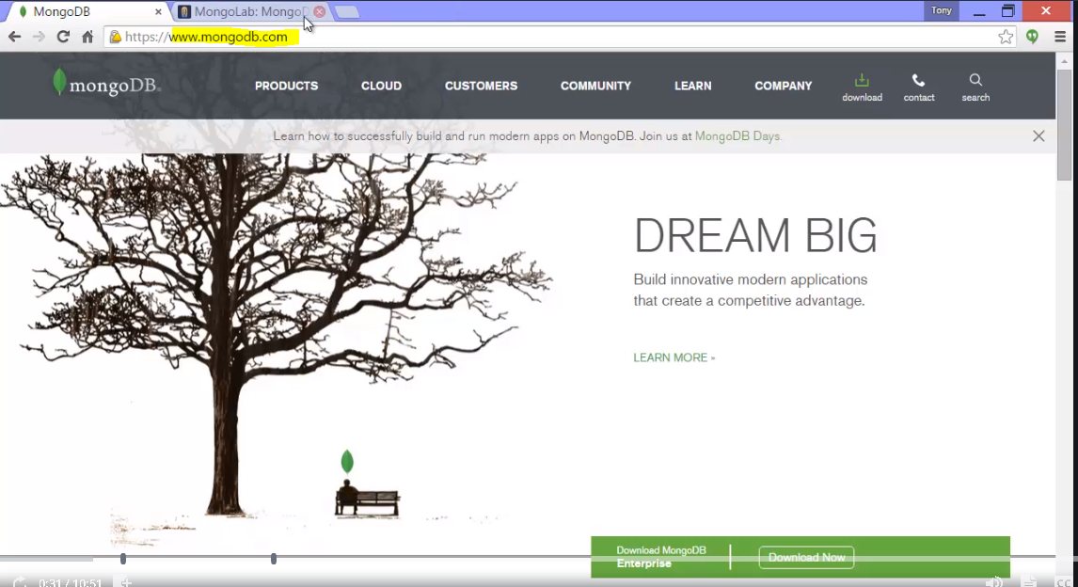

Now, for the purposes of this course, I wanted to quickly be able to set up a MongoDB database and show you the contents.

**One nice way to do this was by going to mongolab.com which provides me a very simple and easy way to create a MongoDB out on the cloud, and after I signed up for MongoLab I could go ahead and create a new database**

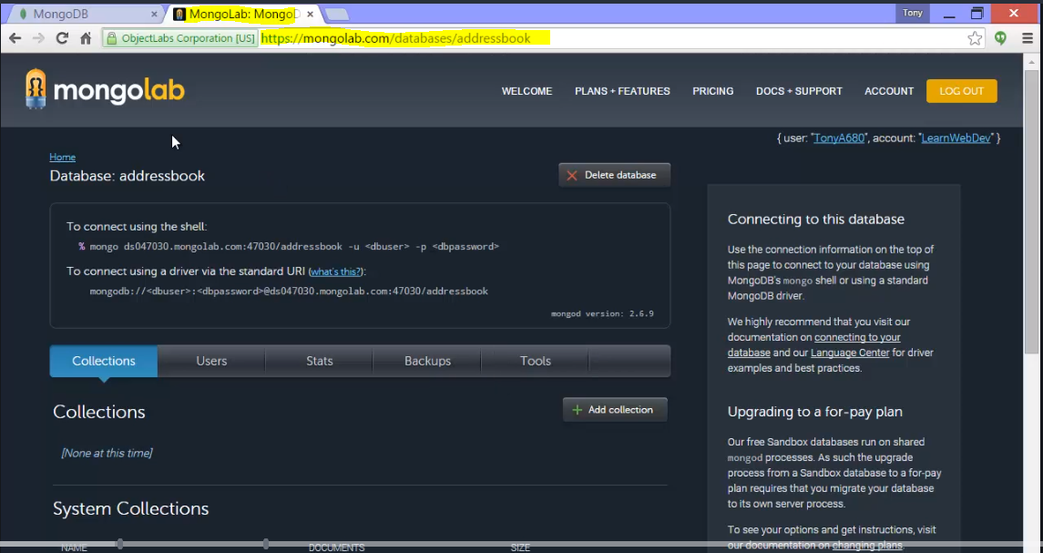

but when I created a new database, I created what was called a single Node which is free, it's 500 megabytes. So, I could just create a free database just to learn to mess around with Mongo

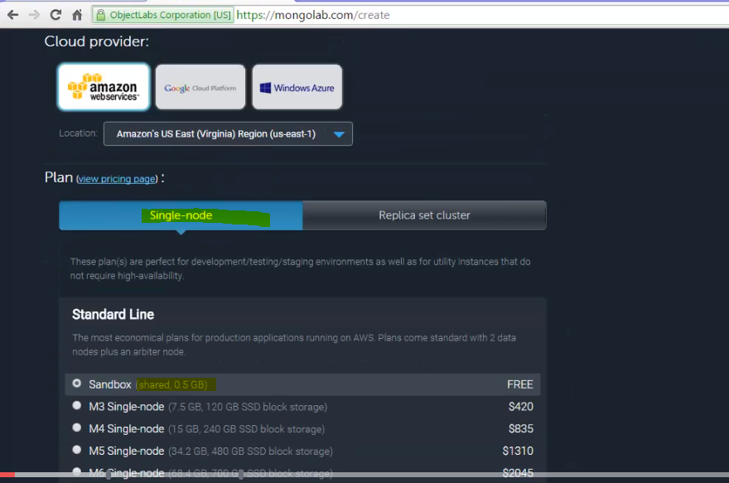

and if you like to use MongoLab or one of the other cloud storages that has a small free database available, you can do that too instead of installing it locally.

**It also gave me a URL to connect to which I can use in my code,**

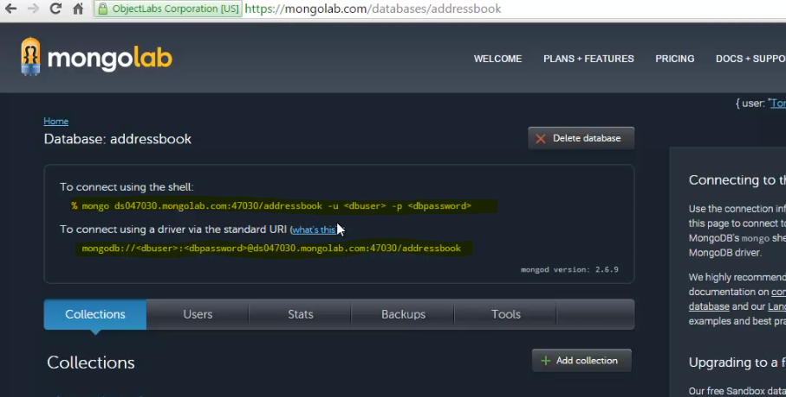

Now look at mongoose package 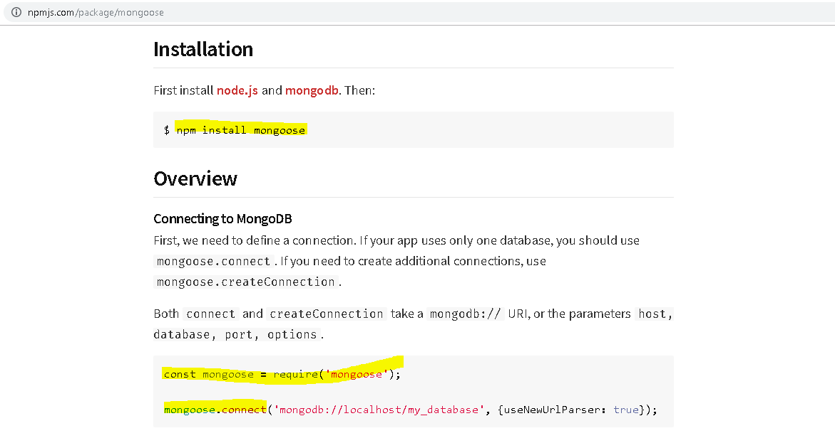

The NPM package we'll be using is the very popular Mongoose, which is designed for dealing with MongoDB and doing it in a very consistent, clean way. I can install it with NPM install Mongoose, and I would simply then require Mongoose and I can connect using the MongoDB URL. MongoLab gave me one or you might have your own localhost URL if you installed it locally or at 127.0.0.1 instead of localhost, sometimes depending on your setup.

But whatever the case is, you can connect to your MongoDB, and then you set up what's called a schema, meaning this is what my objects will look like, this is what my document will look like,

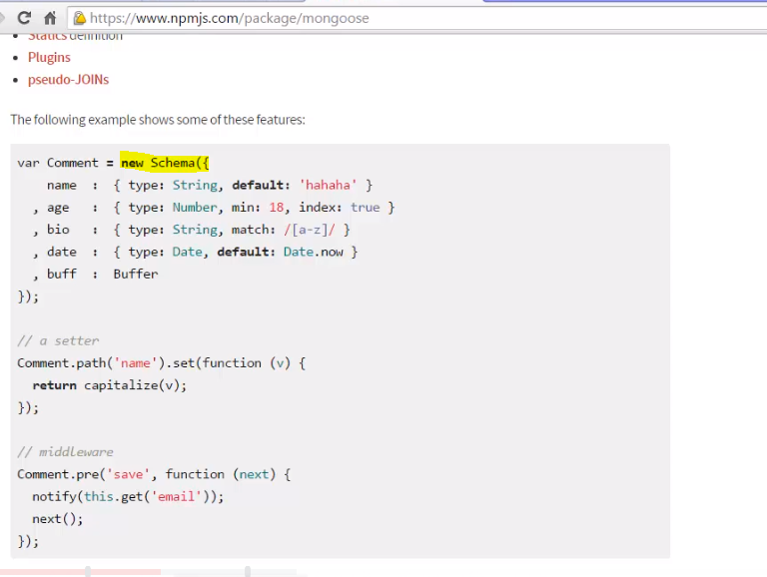

**then that schema essentially becomes almost like a function constructor inside Node, so I can create new objects, and then save them directly to the database, and remember, we're not saving to tables, we're saving all of the data, including the structure in a format that's essentially like JSON that MongoDB calls BSON.**

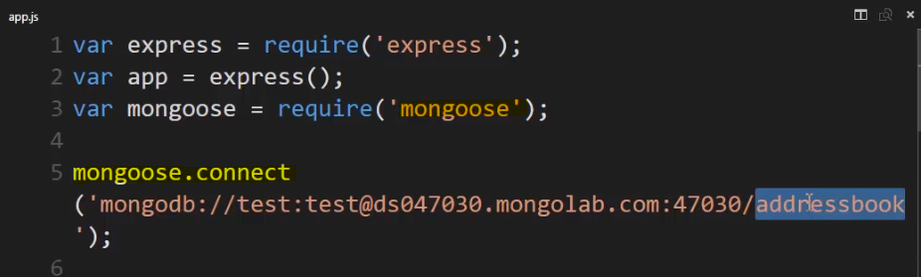

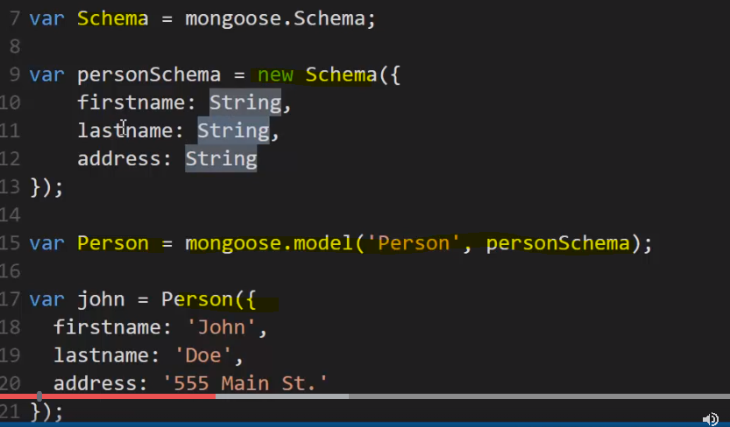

Mongoose provides this constructor called schema, so I'll just set a variable for it, mongoose.schema. This let's me define the structure of a document, so I can say I want this new schema, and I give it a JavaScript object, and I give it the names of the properties and the types of data that they'll store, and there's a variety of types. In our case it's just strings, firstname, lastname, address is all we want to store. Once I have the schema, I can then generate a function constructor, what is essentially a function constructor, but we don't use it exactly the same way but it does generate objects, it is a constructor and mongoose.model let's me give it a name, and then the schema. So, in other words, what do we expect from the objects that we're going to create using this schema? What's the structure? And then I can create new instances or new versions of this object, this type of object that follows this structure.

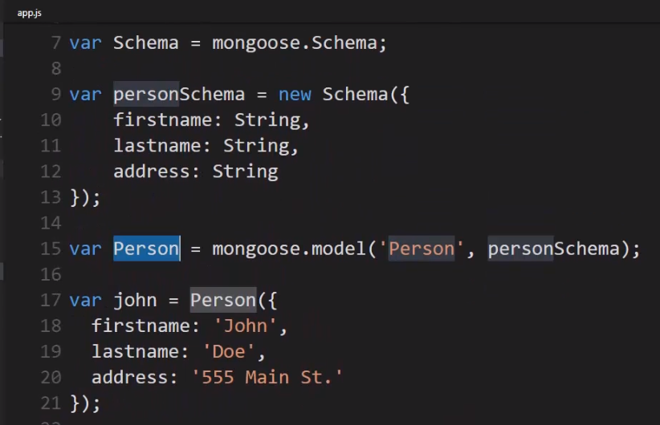

**So again, I created a schema that said what should the properties be and what types of data, which allowed me to then create this function which will generate objects that are Mongoose objects that will then allow me to store the data in MongoDB and then I start creating individuals objects. These will be individual documents ultimately.**

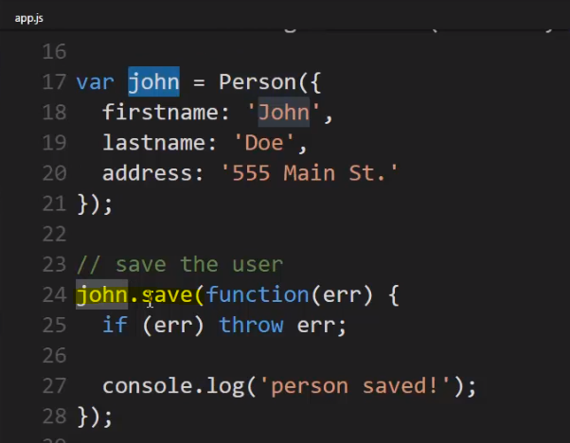

**So, John is a person, and unlike a function constructor, I don't say new, I just give it the object that I want to save. So, firstname, lastname, address but because I called this person function, and person is a model, then any object returning back from person will have some methods on it, like save.**

**So, .save will save this document into that proper area in MongoDB as expected by that particular schema, that structure, so I can call .save on my new object and give it a call back, and if there's an error, I can handle it**

and then I'll create a Jane object a new person, do the same thing. She's a person. I give it an actual object literal, storing the data that matches the structure, and then I save

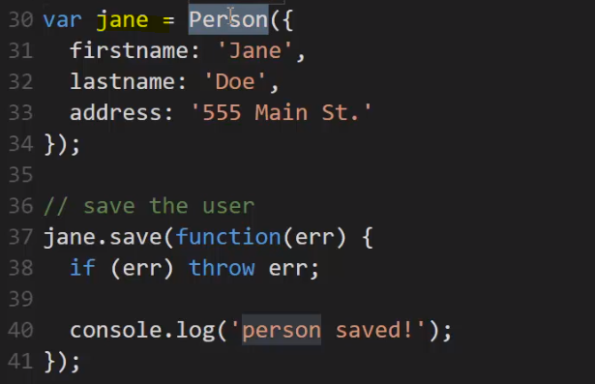

then what I did was a bit later in the middleware for when we load the web page, I just wanted to console.log the query where I go and ask for the data. In this case I'm just asking for everything. In here I could potentially put specific queries, things that I'm looking for, and then I'm going to output what I get back. So, all I'm doing is setting up the structure, putting in a couple pieces of data and getting data out.

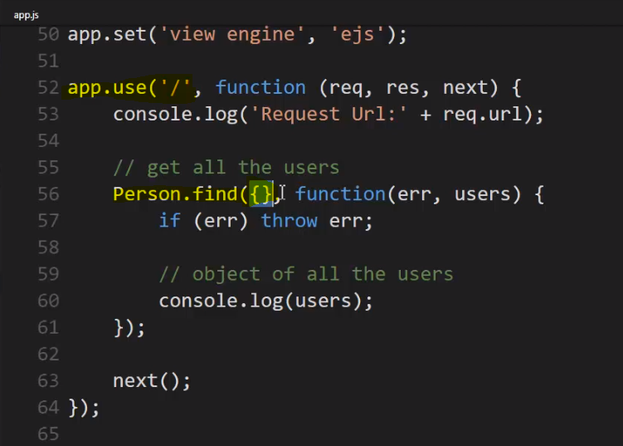

**Lets run the app-**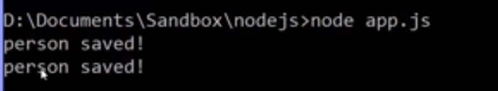

I'll just run node app.js and I get two persons saved logs, so they're both saved, and

I'll go to localhost 3000 to cause the middleware to run



and there it is. I got back from MongoDB via Mongoose, JavaScript objects in array.

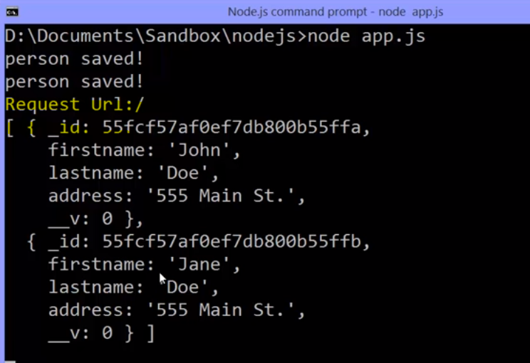

Now if I go over to MongoLab and refresh to see what's inside here, I have a collection. That was that person schema,

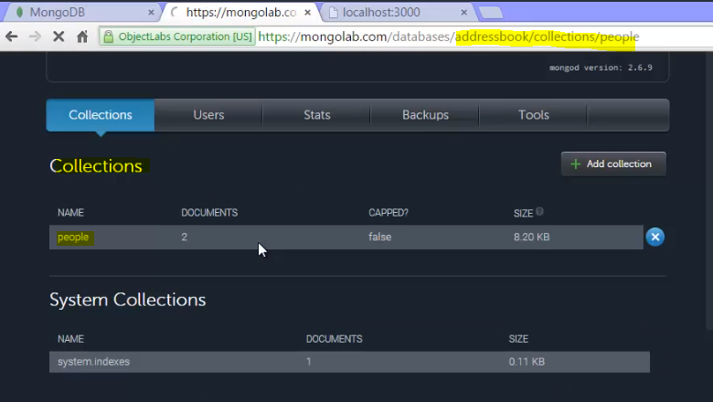

and inside of it I have multiple documents.

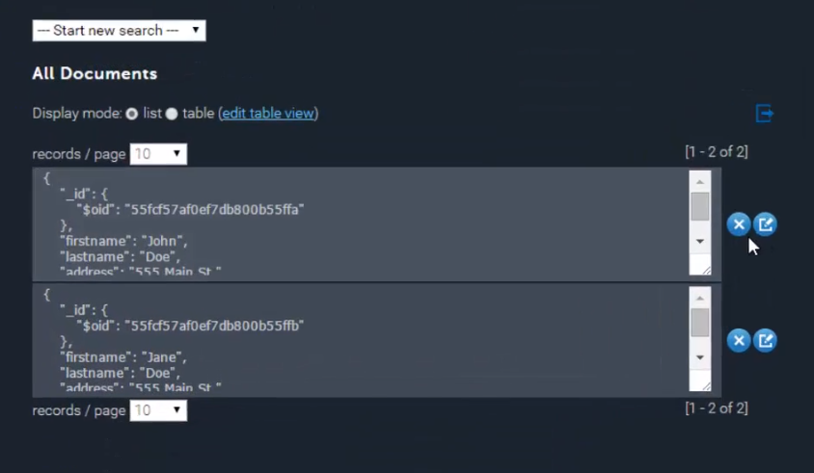

It's not a table, I don't have rows. Each document contains everything, both the structure and the data and when I queried it it gave me this back. I notice this looks very similar to JSON. That's how Mongo stores data. It's a document database

and each one of these is a document and I can query it.

I can say find me one where the first name is this or find me one where the address is this etc. Or where something is greater than or less than or just normal things you're used to when asking, querying information about data.

**but what's so great about this is that the structure that Mongo stores data in is very similar to the way that JavaScript stores data in objects.**

**Each object has its own structure, its name value pair, its properties, and so if inside my document database, one of these documents had a slightly different structure than the other, it's not going to complain, JavaScript is fine with that because each object stands alone but all of them can sit inside the same array, even if each object is different. So, I could get back a variety of objects with different or slightly different structures and I can just use that in JavaScript without any problems.**

So, the idea here is that the way Mongo stores data ties very nicely to JavaScript itself and the way Node then is going to work with objects.

**It's very simple to simply say here's my data and pass it along for the ride and give me some data and get it back and just work with it very naturally. It's kind of similar to MySQL but we're also gaining the advantage of being able to change our structure on the fly because it's a NoSQL approach to storing data. Each document also stores its own structure with it.**

Does that make sense?

So, this is why Mongo and Node together is very popular but you certainly don't have to use Mongo with Node but you can and there's this terrific NPM package called Mongoose that makes it a lot easier to do.

## **WebServer Checklist**

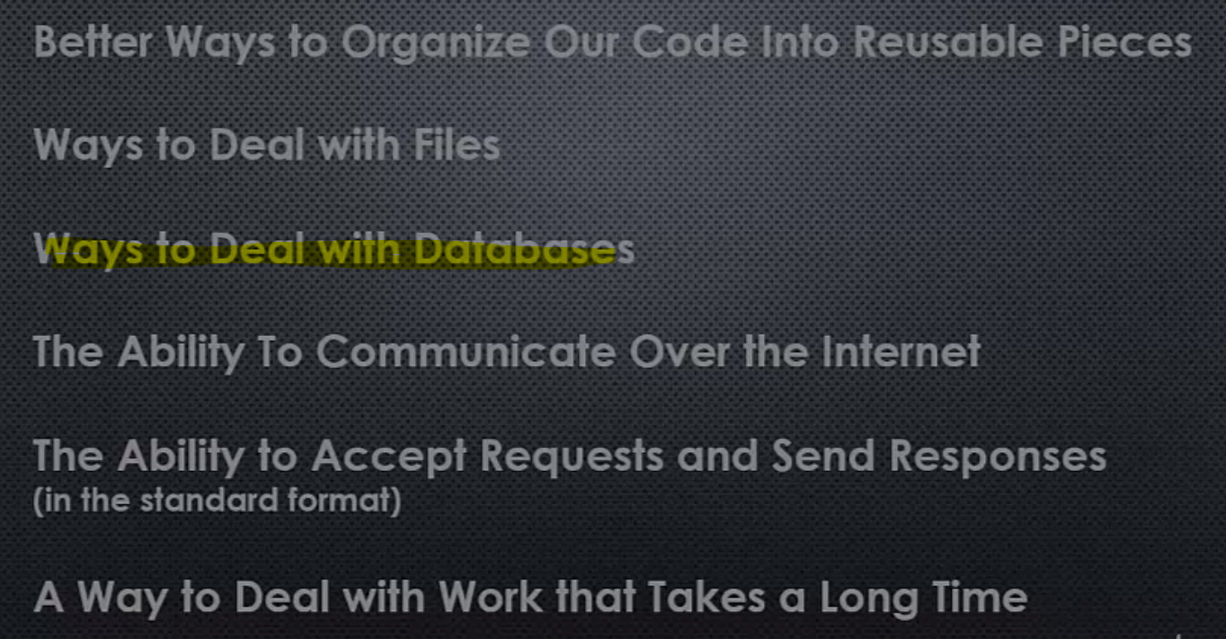

**We've seen already how modules, asynchronous files, the ability to communicate over the internet, to accept requests and send responses in HTTP, to work with data that takes a long time to load or other processes that take a long time to load through streams and buffers and asynchronous calls, and now we see that Node has plenty of ways to deal with databases.**

**So, what does that make Node?**

**A complete and robust web server technology. And, we can use it to build websites and web applications. And, I hope you see how fun it can be in Node, especially leveraging the power of the JavaScript programming language and the things that Node added on to JavaScript.**